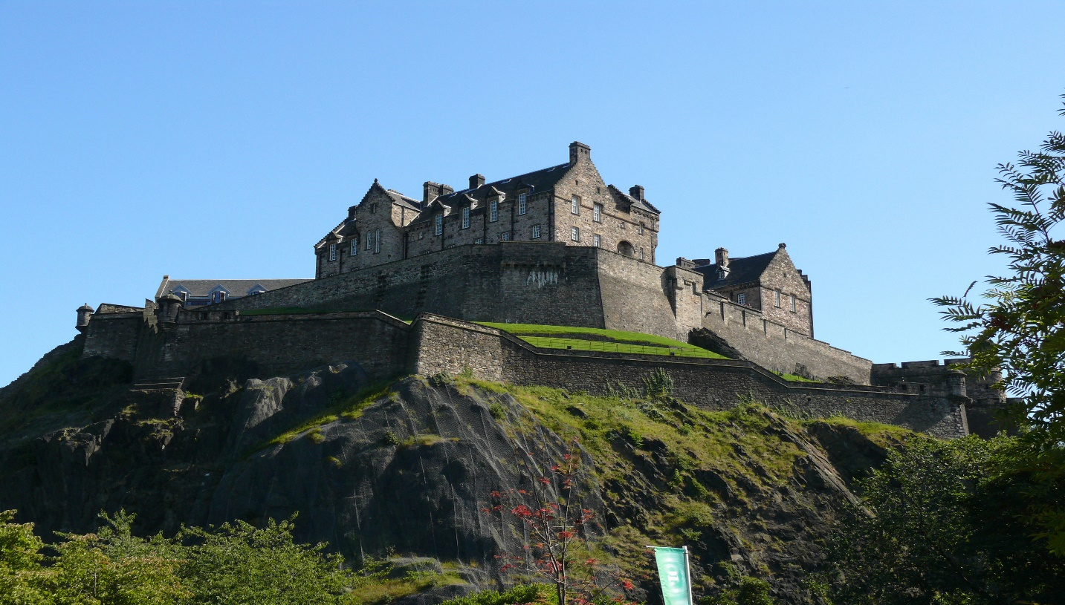

# Edinburgh Castle

**Edinburgh Castle** is a historic [castle](https://en.wikipedia.org/wiki/Castle) in [Edinburgh](https://en.wikipedia.org/wiki/Edinburgh), [Scotland](https://en.wikipedia.org/wiki/Scotland). It stands on [Castle Rock](https://en.wikipedia.org/wiki/Castle_Rock_(Edinburgh)), which has been occupied by humans since at least the [Iron Age](https://en.wikipedia.org/wiki/Iron_Age). There has been a royal castle on the rock since the reign of [Malcolm III](https://en.wikipedia.org/wiki/Malcolm_III_of_Scotland) in the 11th century, and the castle continued to be a royal residence until 1633. From the 15th century, the castle's residential role declined, and by the 17th century it was principally used as a [military](https://en.wikipedia.org/wiki/Military) [garrison](https://en.wikipedia.org/wiki/Garrison). Its importance as a part of Scotland's national heritage was recognised increasingly from the early 19th century onwards, and various restoration programmes have been carried out over the past century and a half.

Edinburgh Castle has played a prominent role in [Scottish history](https://en.wikipedia.org/wiki/History_of_Scotland), and has served variously as a [royal residence](https://en.wikipedia.org/wiki/Palace), an [arsenal](https://en.wikipedia.org/wiki/Arsenal), a [treasury](https://en.wikipedia.org/wiki/Treasury), a [national archive](https://en.wikipedia.org/wiki/National_archives), a [mint](https://en.wikipedia.org/wiki/Mints_of_Scotland), a [prison](https://en.wikipedia.org/wiki/Prison), a military fortress, and the home of the [Honours of Scotland](https://en.wikipedia.org/wiki/Honours_of_Scotland" \o "Honours of Scotland) – the Scottish [regalia](https://en.wikipedia.org/wiki/Regalia). As one of the most important strongholds in the [Kingdom of Scotland](https://en.wikipedia.org/wiki/Kingdom_of_Scotland), the castle was involved in many historical conflicts from the [Wars of Scottish Independence](https://en.wikipedia.org/wiki/Wars_of_Scottish_Independence) in the 14th century to the [Jacobite rising of 1745](https://en.wikipedia.org/wiki/Jacobite_rising_of_1745). Research undertaken in 2014 identified 26 sieges in its 1,100-year history, giving it a claim to having been "the most besieged place in Great Britain and one of the most attacked in the world".[[4]](https://en.wikipedia.org/wiki/Edinburgh_Castle#cite_note-4) Few of the present buildings pre-date the Lang Siege of [1573](https://en.wikipedia.org/wiki/1573), when the medieval defences were largely destroyed by artillery bombardment. The most notable exceptions are [St Margaret's Chapel](https://en.wikipedia.org/wiki/St_Margaret%27s_Chapel) from the early 12th century, which is regarded as the oldest building in Edinburgh,[[5]](https://en.wikipedia.org/wiki/Edinburgh_Castle#cite_note-eotca-5) the Royal Palace, and the early 16th-century Great Hall. The castle is the site of the [Scottish National War Memorial](https://en.wikipedia.org/wiki/Scottish_National_War_Memorial) and the [National War Museum](https://en.wikipedia.org/wiki/National_War_Museum). The [British Army](https://en.wikipedia.org/wiki/British_Army) is still responsible for some parts of the castle, although its presence is now largely ceremonial and administrative. The castle is the regimental headquarters of the [Royal Regiment of Scotland](https://en.wikipedia.org/wiki/Royal_Regiment_of_Scotland) and the [Royal Scots Dragoon Guards](https://en.wikipedia.org/wiki/Royal_Scots_Dragoon_Guards) and houses their [regimental museums](https://en.wikipedia.org/wiki/Regimental_museum), along with that of the [Royal Scots](https://en.wikipedia.org/wiki/Royal_Scots).

The castle, in the care of [Historic Environment Scotland](https://en.wikipedia.org/wiki/Historic_Environment_Scotland), is Scotland's most (and the [United Kingdom](https://en.wikipedia.org/wiki/United_Kingdom)'s second most) visited paid tourist attraction, with over 2.2 million visitors in 2019[[6]](https://en.wikipedia.org/wiki/Edinburgh_Castle#cite_note-ALVA_2019_visitor_numbers-6) and over 70 percent of leisure visitors to Edinburgh visiting the castle.[[7]](https://en.wikipedia.org/wiki/Edinburgh_Castle#cite_note-7) As the backdrop to the [Royal Edinburgh Military Tattoo](https://en.wikipedia.org/wiki/Royal_Edinburgh_Military_Tattoo) during the annual [Edinburgh Festival](https://en.wikipedia.org/wiki/Edinburgh_Festival), the castle has become a recognisable symbol of Edinburgh in particular and of Scotland as a whole.

## **History**

Diagram of a crag and tail feature, such as the Castle Rock: **A** is the crag formed from the volcanic plug, **B** is the tail of softer rock, and **C** shows the direction of ice movement. In the case of Edinburgh, the castle stands on the crag (**A**) with the Royal Mile extending along the tail (**B**)

The castle stands upon the [plug](https://en.wikipedia.org/wiki/Volcanic_plug) of an [extinct volcano](https://en.wikipedia.org/wiki/Extinct_volcano), which is estimated to have risen about 350 million years ago during the lower [Carboniferous](https://en.wikipedia.org/wiki/Carboniferous) period. The Castle Rock is the remains of a [volcanic pipe](https://en.wikipedia.org/wiki/Volcanic_pipe), which cut through the surrounding [sedimentary rock](https://en.wikipedia.org/wiki/Sedimentary_rock) before cooling to form very hard [dolerite](https://en.wikipedia.org/wiki/Dolerite), a type of [basalt](https://en.wikipedia.org/wiki/Basalt). Subsequent [glacial erosion](https://en.wikipedia.org/wiki/Glaciology) was resisted by the dolerite, which protected the softer rock to the east, leaving a [crag and tail](https://en.wikipedia.org/wiki/Crag_and_tail) formation.[[8]](https://en.wikipedia.org/wiki/Edinburgh_Castle#cite_note-8)

The summit of the Castle Rock is 130 metres (430 ft) above sea level, with rocky cliffs to the south, west, and north, rising to a height of 80 metres (260 ft) above the surrounding landscape.[[9]](https://en.wikipedia.org/wiki/Edinburgh_Castle#cite_note-9) This means that the only readily accessible route to the castle lies to the east, where the ridge slopes more gently. The defensive advantage of such a site is self-evident, but the geology of the rock also presents difficulties, since basalt is extremely impermeable. Providing water to the Upper Ward of the castle was problematic, and despite the sinking of a 34-metre (112 ft) deep well, the water supply often ran out during drought or siege,[[10]](https://en.wikipedia.org/wiki/Edinburgh_Castle#cite_note-10) including during the Lang Siege in 1573.